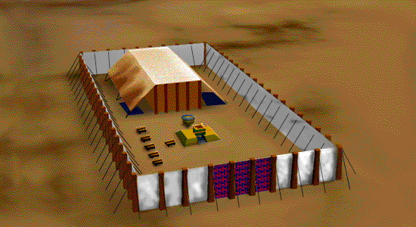
4

–IN THE TABERNACLE–

gold—DIVINE NATURE
blue—HEAVENLY
purple—ROYALTY
scarlet—REDEMPTION; BLOOD
fine linen—RIGHTEOUSNESS; PURITY

Holy Place – Ex. 26:1,29

Holy Garments – Ex 28:4,5

- The colors of the priest’s garments were the same as the colors of the tabernacle in which they ministered.

- Christ is the perfect fulfillment of the tabernacle type.

- Our lives as believers must be in perfect harmony with Christ.

God gives grace
To the humble
Who serve
in harmony with Christ.
Adult Sunday School

1
September 2, 2007

CLOTHED WITH HUMILITY
I Peter 5:1-11

TEXT: I Peter 5:5

I. Clothing is for Service
Ready to go & serving God.

1. It’s God’s will that we be humble.

I Peter 5:5 ‘be clothed with humility’
I Peter 5:6 ‘humble yourselves’
I Peter 5:10 Humbly suffering till Christ is completely obeyed.

Always remember all suffering is a test. I Pt. 1:7

Christ is looking for obedience with humility.
Matthew 11:29
Philippians 2:5-8
I Peter 4:1,12,19

James 4:9-10
II Chronicles 7:14
II Corinthians 12:21
Matthew 5:3
Luke 6:20-31-35
Luke 17:9
Humility is simply having the
2
right estimation of one’s self.

True Humility always seeks to be like Jesus.

2. It’s God’s grace that is for the humble.

I Peter 5:5 ‘giveth grace to the humble’

a. All our service is by His grace.
I Peter 4:10

b. His grace only works through humility
John 1:16 James 4:6
II Corinthians 8:9 I Peter 3:7

c. Christ is our great and perfect pattern of Humility
II Cor. 9:8 ‘with all grace’
II Corinthians 8:9 Phil. 2:5-9
John 13:

3. It’s God’s will that we serve Him with humility.

I Peter 4:10 ‘minister – good stewards’
I Peter 4:1 ‘arm yourself likewise’
I Peter 5:10 ‘hath called us’
Micah 6:8 Romans 12:3
a. The Grace of Humility shows itself in the ability to see God glorified, praised, worshipped and loved.
3
I Peter 4:11, 13-14,16; 5:7

b. Humility opposes pride.
I Peter 4:15; 5:5, 8-9

4. Knowing the grace of God in Truth.

I Peter 5:5 ‘God giveth grace’
I Peter 5:10 God is ‘the God of all grace’

Grace and truth come together.
John 1:16,17 I Peter 1:13-14,22-23
II Peter 1:2 II Peter 3:18
Colossians 1:6 Psalm 25:9

a. Recognize your need to be taught.

b. Acknowledge spiritual need.

c. Always exalt Jesus everywhere you go.
I Peter 3:15 II Cor. 2:14-17
I Peter 5:1-4

